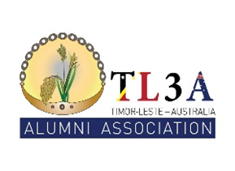

TL3A Membership, Sector Group enquiries and new contact details form
If you are an Australia Awards Alumni and would like to
- join the Timor-Leste Australia Alumni Association (TL3A),
- join or find out more about a TL3A sector group
- update your contact and/or employment details
please fill out the form below and send your details to the Alumni Secretariat Office by email to alumni@australiaawardstl.org
- Personal details:
- Name :
- Home address :
- Mobile phone :
- WhatsApp no :
- E-mail address :
- Facebook name :

- There are currently seven TL3A Sector Groups. They are a great way to work with other alumni and giveback to Timor-Leste’s development. If you would like to join, or find out more information, please tick one or more of the follow:
- Agriculture Sector
- Development Sector
- Education Sector
- Health Sector
- Infrastructure Sector
- Media and Communication (M&C)
- Sport Group

- Current employment details

Employer name:
Job title:

Please Send your completed form to Alumni Secretariat at WDPTL by email to alumni@australiaawardstl.org

